**Requirements Documentation**

**Brief Description**

The project is to create a Library website where Users will be able to see a list of books. Admins will be able to add, remove or update information for a book. Search books by name. Search functionality should support partial name matches and simple mistakes in spelling.

1. Functional requirements
   1. The system must contain an authentication process for the admin and the users.
   2. Admin will be able to add and delete any information.
   3. Admin will be able to view and edit all information.
   4. Search functionality should support partial name matches and simple mistakes in spelling.
2. Nonfunctional requirements
   1. Operational requirements

a.1. The admin will have access to the system through a unique login id.

a.2. The system should be able to run in any web browser.

1. Performance requirements

b.1. Must allow multiple login at a time without lagging.

b.2. The system must not crash more than once in any one day.

b.3. The system must have enough space for allowing uploading data.

b.4. The system must be organized in such a way that user errors are minimized.

1. Security requirements

c.1. Only admin can access all files and data.

c.2. The users can only access the specific sites.

c.3. The system must be safe and secure enough to prevent any theft or loss of data.

d. Cultural and political requirements

d.1. The system should support for multiple language for example, Bangla, English etc.

d.2. the system can be used outside of the premises of the organization.

**Usecase Diagram:**

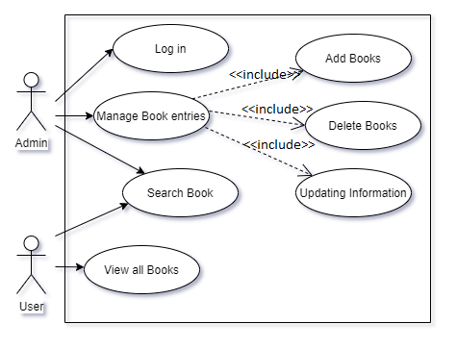

**Sequence Diagram:**

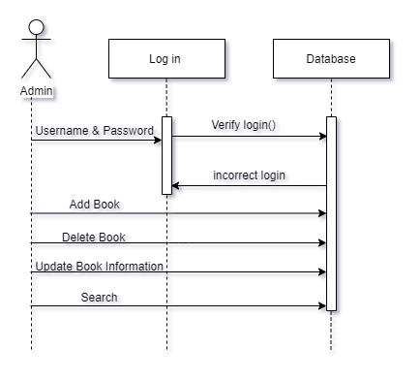

Software requirements:

Python-Flask: Latest

Pip3 installation

Sqlalchemy

Flask-sqlalchemy

Json

Pytest

Postman

Docker